OPTIMET-3D: User Manual

A software package for simulating electromagnetic wave interaction with a cluster of dielectric, metallic, and semiconducting spheres embedded in a homogeneous background

Ahmed Al-Jarro, Mayeul D’Avezac and Nicolae C. Panoiu

Version 2.0

25 January 2017

# OPTIMET-3D User Manual

## OPTIMET-3D (OPTIcal METamaterials - 3Dimensional) is an *ab initio* solver for 3D electromagnetic wave scattering problem. OPTIMET-3D is distributed under the GPL. It is freely available on [GitHub](https://www.github.com/OPTIMET/OPTIMET) ([https://GitHub.com/OPTIMET/OPTIMET](https://github.com/OPTIMET/OPTIMET)) for all interested parties. It includes a description of the installation steps, as well as this usage manual.

## OPTIMET-3D implements the multiple-scattering matrix (MSM) method, used to accurately describe the electromagnetic wave interaction with a cluster of an arbitrary number of dielectric, metallic, or semiconducting spheres embedded in a homogeneous background medium. The features of OPTIMET-3D are instrumental for efficient modelling of light interaction with ensembles of nano-particles. In particular, OPTIMET-3D can be used to investigate scientific problems arising in several different disciplines, including Engineering, Physics, Chemistry, Materials Science, and Biology.

**OPTIMET-3D** is written in C++ programming language and uses the OOP framework. **OPTIMET-3D** provides the source code and an intuitive scripting system as the data input, in XML format, for running the executable. The source code and installation process are available via the GitHub public repository [OPTIMET-3D](https://github.com/OPTIMET/OPTIMET). **OPTIMET-3D** employs a set of functions for efficient handling of algebraic operations and numerical computations that are related to the MSM formalism. In addition, **OPTIMET-3D** incorporates a set of routines and scientific libraries for the serial or parallel execution of the resulting system of linear equation, which can be solved directly or iteratively. For the parallel execution, it accepts several linear-systems solvers found in, for example, [Scalapack](http://www.netlib.org/scalapack/) for the direct solution and [Belos](https://trilinos.org/packages/belos/) for an iterative solution.

To use **OPTIMET-3D**, simply copy the executable Optimet3D to a folder of your choice, set your shell to the folder where Optimet3D is stored and call it using a single argument, the path to the input file. For example, ./Optimet3D input-filename.

In order to become familiar with and learn how to use **OPTIMET-3D**, refer to the detailed information provided in what follows, about the XML input system and simulation parameters.

# Introduction

Computational techniques based on the multiple-scattering matrix (MSM) method have become a primary means for modelling a variety of scientific and engineering problems pertaining to electromagnetic waves interaction with systems of arbitrarily distributed particles [1-3]. In particular, computational methods based on the MSM algorithm, also called the *transfer matrix* (or *T*-*matrix*) method, play a central role in modelling photonic materials, metamaterials, nano-photonic devices, wireless communications devices, radar signature technology, antennae, microwave devices, bio-photonics and biomedical imaging and sensing. The versatility of the MSM method allows one to study electromagnetic waves interaction with ensembles of scatterers under a broad set of boundary conditions, material parameters and geometries.

**OPTIMET-3D** implements the MSM method and consequently it can be used to describe the interaction of electromagnetic waves with arbitrary distributions of dielectric, metallic and semiconducting particles.

The main part of the MSM algorithm consists in constructing and solving a system of linear equations whose unknowns are the Fourier coefficients of the scattered field. The matrix defining this system is completely defined by the location, shape and material parameters of the cluster of particles. The *T*-matrix of the system has a block structure, the corresponding blocks consisting of single-particle *T*-matrices and matrices that describe bi-particle interactions (electromagnetic coupling between two particles). As an immediate consequence of this block structure of the *T*-matrix, the MSM method can be easily applied to modelling clusters with arbitrary number and distribution of particles.

The main advantages of **OPTIMET-3D** are:

1. The electromagnetic field is computed using a relatively small set of parameters, which leads to a significant reduction in the computational time.
2. It inherently satisfies the far-field radiation boundary condition and therefore it does not require a computational grid.
3. It can be used to model a broad class of material properties (particles made of dielectric, metallic semiconducting and polaritonic materials).

# The OPTIMET-3D XML Input File Manual

**OPTIMET-3D** uses an eXtended Markup Language (XML) input file to setup the numerical simulation. The .xml file contains the set of parameters required for a simulation and its (meta)name will be appended to the output data file, which is written in HDF5 file format .h5. When launching a simulation, the .xml file name needs to be passed as an input parameter to the Optimet3D executable, *without* the .xml extension.

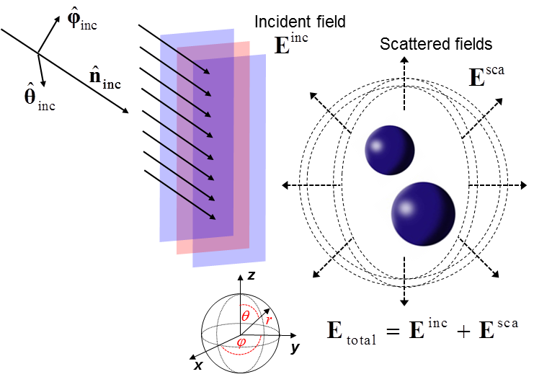

***Figure 1****. Schematic representation of the incident and scattered fields for a two-particle scattering system.*

The .xml file contains several blocks describing different aspects of the simulation problem. The order in which these blocks are defined in the .xml file is irrelevant. However, it is the user’s responsibility to correctly define all of the main blocks of a simulation.

**OPTIMET-3D** implements the MSM method, which we briefly outline in what follows. Thus, consider a cluster of *N* particles being illuminated by a monochromatic plane electromagnetic wave. The origin of the co-ordinate system of the cluster is $O$ and to each particle (*j*) one associates a co-ordinate system with the origin, $O_{j}$. The only constraint imposed on the location of the particles is that the circumscribing spheres of the particles do not overlap, *i.e*. $\left|R_{jl}\right|=\left|O_{j}-O_{l}\right|≥ρ_{j}+ρ_{l}$, $j,l=1,2,…,N, j≠l$, where $ρ_{j}$ is the radius of the smallest sphere containing the *j*th particle (see ***Figure 1***).

The solution of the source-free Maxwell equations in 3D can be expanded in a complete basis of vector spherical wave functions, $\left(M_{mn}^{(1)},N_{mn}^{(1)}\right)$ and $\left(M_{mn}^{(3)},N_{mn}^{(3)}\right)$. In a practical implementation, the series is truncated to a certain order, $n_{max}$. Let $\sum_{mn}{≝}\sum_{n=1}^{n_{max}}{\sum_{m=-n}^{n}{;}}$ then, the incident, scattered and internal electric fields can be expressed as:

incident field

$E_{0}^{inc}\left(R\right)=\sum_{mn}{\left[a_{mn}M_{mn}^{(1)}\left(kR\right)+b_{mn}N_{mn}^{(1)}\left(kR\right)\right]}, \left(1\right)$

internal field

$E^{int}\left(R_{j}\right)=\sum_{mn}{\left[c_{mn}^{j}{RgM}_{mn}^{(1)}\left(k_{j}R_{j}\right)+d_{mn}^{j}{RgN}_{mn}^{(1)}\left(k_{j}R_{j}\right)\right]}, R_{j}<ρ_{j}, \left(2\right)$

scattered field

$E^{sca}\left(R_{j}\right)=\sum_{mn}{\left[p_{mn}^{j}M_{mn}^{(3)}\left(kR_{j}\right)+q_{mn}^{j}N_{mn}^{(3)}\left(kR_{j}\right)\right]}, R_{j}>ρ_{j}, \left(3\right)$

where $k$ and $k_{j}$ are the wave vectors in the embedding medium and inside the *j*th particle, respectively, $R$ and $R_{j}$, $j=1,2,…,N$, are the position vectors of a point, *P*, in the co-ordinate systems $O$ and $O_{j}$, respectively. It can be demonstrated that, within the MSM method, computing the scattering coefficients $p_{mn}^{j}$ and $q_{mn}^{j}$, and implicitly the electromagnetic field and system cross-sections, amounts to solving a linear system $Sv=u$, where $v$ is a vector determined by the scattering coefficients, $u$ is a known vector determined by the incoming field coefficients, and $S$ denotes the scattering matrix of the system. Constructing the system matrix $S$ and solving the corresponding linear system represent the core parts of the MSM method.

In **OPTIMET-3D**, all length values are to be given in nanometers (${10}^{-9} m$), with the scale factor (${10}^{-9}$) suppressed throughout. For example, the radius parameter of a sphere with radius of $500×{10}^{-9} m$ is defined as radius="500.0". The angles that define the direction of an incident plane-wave are given in degrees. The amplitude of the electric field of an incoming plane-wave is given in units of V/m. As a general rule, unless otherwise specified, all physical quantities are specified in SI units. In the following sub-sections, the complete procedure of defining the building blocks of an XML file is described.

## Simulation

### The Simulation Block

The Simulation Block describes the overall properties of performing a simulation. The main property required for this block is the maximum number of Fourier harmonics, nmax, which must be a positive integer, nmax > 0. The parameter nmax is used to define the size of the vectors containing the expansion coefficients used for representing an incident plane-wave and the scattered field [1]. In order to accurately solve a specific scattering problem, the choice of the value of nmax will mostly depend on the operating wavelength, the size of the spherical particles, their electromagnetic properties and spatial distribution.

The syntax for a Simulation Block that defines a simulation with nmax="20" harmonics is:

{.xml}

<simulation>

<harmonics nmax="20" />

</simulation>

### Execution Block

The Simulation Block in its native format, as shown in section 2.1.1, will solve the resulting system of linear equations directly and in serial. The ParameterList Block defines the specifics to how the linear system is solved, which makes use of the [Belos](https://trilinos.org/packages/belos/) scientific library that offers a range of linear system solvers. In what follows, we list the use of several options: eigen scalapack and GMRES.

The syntax that defines a direct and serial solution that makes use of eigen solver is:

<ParameterList name="Belos">

<Parameter name="Solver" type="string" value="eigen"/>

</ParameterList>

In order to speed up the process required for solving the resulting system of linear equations, one of the following three options can be used: i) parallel only, ii) parallel and iterative, iii) parallel and iterative that is combined with fast matrix multiplication (FMM) technique [4], [5]. For the parallel execution, the number of processes is set according to user’s submission file that is used for the target parallel computing system.

The syntax that defines a parallel and direct solution that makes use of scalapack solver is:

<ParameterList name="Belos">

<Parameter name="Solver" type="string" value="scalapack"/>

</ParameterList>

The syntax that defines a parallel and iterative solution that makes use of GMRES solver is:

<ParameterList name="Belos">

<Parameter name="Solver" type="string" value="GMRES"/>

<Parameter name="Maximum Iterations" type="int" value="4000"/>

<Parameter name="Output Frequency" type="int" value="20"/>

</ParameterList>

The syntax that defines a parallel and iterative solution, by means of the GMRES method, that is combined with the FMM technique is:

<FMM subdiagonals="2"/>

<ParameterList name="Belos">

<Parameter name="Solver" type="string" value="GMRES"/>

<Parameter name="Maximum Iterations" type="int" value="4000"/>

<Parameter name="Output Frequency" type="int" value="20"/>

</ParameterList>

The FMM block takes as an option subdiagonal=N where N is a parameter used to determine which elements are computed using local data in the FMM parallelization scheme. Those elements which are on the diagonal or within the band containing N (upper and lower) subdiagonals are computed using local data. By default, when subdiagonal is omitted, which is the recommended setting, it is set such that as many (*i*, *j*) interactions are computed with local data as with non-local data.

## The Source Block

The Source Block defines the excitation (or incoming wave) that acts upon the scattering system. A Source Block is defined by its type, operating wavelength, incident wave vector, and polarization of the incident field.

The propagation of the incident plane-wave is specified in spherical coordinates $\left(θ_{inc}, φ_{inc}\right)$, which are defined with respect to a system with the origin located at (0, 0, 0), as shown in Fig. 1. Then, the incident electric field is defined as $E^{inc}=E_{θ}^{inc}{\hat{θ}}_{inc}+E_{φ}^{inc}{\hat{φ}}_{inc}$,where ${\hat{θ}}_{inc}$ and ${\hat{φ}}_{inc}$ are the unit vectors in the $θ$- and $φ$-directions, such that ${\hat{n}}_{inc}={\hat{θ}}_{inc}×{\hat{φ}}_{inc}$ ( ${\hat{n}}_{inc}$ is a unit vector along the direction of the wave vector of the incident wave) and $E_{θ}^{inc}$ and $E_{φ}^{inc}$ are the corresponding field components along ${\hat{θ}}_{inc}$ and ${\hat{φ}}_{inc}$, respectively.

In the definition of the Source Block, the direction of the incident wave vector is defined by the variables (theta, phi), specified in degrees, and the incident plane-wave is defined by the (complex) field projections along ${\hat{θ}}_{inc}$ and ${\hat{φ}}_{inc}$, (Etheta.real, Etheta.imag) and (Ephi.real, Ephi.imag), respectively.

### Plane-wave:

The syntax for a Source Block that defines a linearly polarized incident plane-wave with wavelength of 1460 nm, direction of incidence (theta, phi) = (90, 90) and polarization (Etheta.real, Etheta.imag)=($\sqrt{2}/2$, 0) and (Ephi.real, Ephi.imag)=(0, $\sqrt{2}/2$) is:

{.xml}

<source type="planewave">

<wavelength value="1460" />

<propagation theta="90" phi="90" />

<polarization Etheta.real="0.70710678118" Etheta.imag="0.0"

Ephi.real="0.0" Ephi.imag="0.70710678118"/>

</source>

### Laguerre Gaussian Beam:

The syntax for a Source Block that defines an incident Laguerre Gaussian (LG) beam [1] with wavelength of λ=1460 nm, orbital angular momentum number *l*=4, beam waist *w*0=1.0λ, direction of incidence (theta, phi) = (0., 0.) and polarization (Etheta.real, Etheta.imag)=($\sqrt{2}/2$, 0) and (Ephi.real, Ephi.imag)=(0, $\sqrt{2}/2$) is:

{.xml}

<source type="LG0l">

<wavelength value="1460" />

<orbitalVariation_l value ="4" />

<beamWaistFactor_wo value ="1.0" />

<propagation theta="0.0001" phi="0.0001" />

<polarization Etheta.real="0.70710678118" Etheta.imag="0.0"

Ephi.real="0.0" Ephi.imag="0.70710678118"/>

</source>

We specify that in **OPTIMET-3D** the angles that define the direction of an incident wave are given in degrees. The field components Etheta and Ephi of the incoming plane-wave can have complex values. This allows one to consider incoming plane-waves that are circularly polarized.

## The Geometry Block

The Geometry Block defines the configuration of the simulation, including electromagnetic properties of the particles and background medium, as well as the distribution and size of the particles. By default, the background medium is assumed to be vacuum.

The syntax used for setting the electromagnetic properties of the background to, for example, a medium with relative electric permittivity, $ε_{b}=3$, and relative permeability, $μ_{b}=1$, is:

{.xml}

<geometry>

<background>

<epsilon type="relative" value.real="3.0" value.imag="0.0" />

<mu type="relative" value.real="1.0" value.imag="0.0"/>

</background>

</geometry>

To include a spherical particle in the Geometry Block, the Sphere Object Sub-block (see ***Sec. 2.3.1***) is used for defining its radius, location and electromagnetic properties. The only constraint imposed on the location of a particle and, consequently, the distribution of the particles, is that their circumscribing spheres do not overlap. For this purpose, during the simulation process and prior to solving the scattering problem, **OPTIMET-3D** first checks that this condition is satisfied. Otherwise, an error message is generated and the simulation stops as shown in ***Sec. 3.2***.

***Electromagnetic properties*:** in order to define the electromagnetic properties, the Geometry Block supports three classes of materials:

1. Frequency-independent permittivity and permeability values (both are user defined).

$ε=ε_{0}ε_{r}$ and $μ=μ_{0}μ_{r}$

1. Relative permittivity defined by the Drude model with plasma, $ω_{p}$, and damping, $v$, frequencies, the frequency of the incident plane-wave being $ω$. The plasma and damping frequencies are set by the user, whereas the frequency of the incident plane-wave is implicitly determined from the Source Block (see ***Sec.*** ***2.2***).
$$ε\left(ω\right)=ε_{0}ε_{r}\left(ω\right)=ε_{0}\left[1-\frac{ω_{p}^{2}}{ω(ω+iv)}\right]$$

2. Relative permittivity defined by the Sellmeier equation, defined by the coefficients $\left(B_{i}, C_{i}\right)$ and the wavelength, $λ$, of the incident plane-wave. Currently, up to five terms can be used to define this dispersion model.

$$ε_{r}\left(λ\right)=1+\sum_{i=1}^{5}{\frac{B_{i}λ^{2}}{λ^{2}-C_{i}}}$$

***Location*:** in order to define the location of the particles, the Geometry Block supports two configurations:

1. Sphere Object Sub-block, an object by object distribution of particles.
2. Spiral Structure Sub-block, a predefined spiral-like structure layout of particles. This was introduced merely for testing purposes.

### Sphere Object Sub-block

The sphere object is used to define the location of a particle, as well as its radius and electromagnetic properties. The particle location is defined in Cartesian coordinates.

The syntax used to define a sphere with radius of $500 nm$ and frequency-independent electromagnetic properties set via a relative permittivity $ε_{r}=13$ and relative permeability $μ_{r}=1$, whose centre is located at $\left(100, 50, -200\right) nm$, is:

{.xml}

<geometry>

<object type="sphere">

<cartesian x="100.0" y="50.0" z="-200.0" />

<properties radius="500.0" />

<epsilon type="relative" value.real="13.0" value.imag="0.0" />

<mu type="relative" value.real="1.0" value.imag="0.0"/>

</object>

</geometry>

Note that the trailing .0 in double values is optional. However, if an integer value contains a .0, **OPTIMET-3D** will trigger a warning message before rounding it to an integer.

The syntax that defines a silver (Ag) sphere whose material properties are defined by the Drude model (where the frequency of the incident plane-wave is implicitly determined according to the Source Block) is:

{.xml}

<geometry>

<object type="sphere">

<cartesian x="100.0" y="50.0" z="-200.0" />

<properties radius="500.0" />

<epsilon type="DrudeModel">

<parameters plasma_frequency="1.35e16"

damping_frequency="2.73e13" />

</epsilon>

<mu type="relative" value.real="1.0" value.imag="0.0"/>

</object>

</geometry>

The syntax that defines a silicon (Si) sphere whose relative permittivity is determined by a three-term Sellmeier equation is:

{.xml}

<geometry>

<object type="sphere">

<cartesian x="100.0" y="50.0" z="-200.0" />

<properties radius="500.0" />

<epsilon type="Sellmeier">

<parameters B1="10.66842930" C1="0.301516485"

B2="0.003043475" C2="1.13475115"

B3="1.541334080" C3="1104.0" />

</epsilon>

<mu type="relative" value.real="1.0" value.imag="0.0"/>

</object>

</geometry>

Multiple Sphere Object Sub-blocks can be added to the Geometry Block. This is explicitly illustrated in ***Sec. 3.2***.

### Spiral Structure Sub-block

To illustrate the capabilities of **OPTIMET-3D**, we present in what follows a more exotic cluster of spheres, namely an Archimedean-type spiral defined by the Spiral Structure Sub-block. This structure consists of a certain number of particles arranged in semicircular segments (arms) separated by the same angle. Each arm contains an identical number of spherical particles, the spheres being separated by the same center-to-center distance. The angle that determines the angular distribution of the arms as well as the location of each sphere on the arms are implicitly determined within **OPTIMET-3D**, i.e. the user does not have to manually add each individual object.

The Spiral Structure Sub-block structure is described by the following parameters: *i*) the number of semicircular segments (arms); *ii*) the number of spherical particles (points) placed on each arm, including the sphere located at the centre of the system, which is shared by all arms; *iii*) the plane on which the spiral structure is set, which is defined by a vector perpendicular onto this plane (normal); *iv*) the constant separation distance (distance) between any two adjacent particles on an arm, which is defined by the corresponding centre-to-centre separation distance. It is the user’s responsibility to make sure that this separation distance is larger or equal to the diameter of the spheres, meaning that no two spheres overlap.

The syntax for a Spiral of Spheres Structure Sub-block containing three arms and five spherical particles located on each arm (each sphere has radius $=500 nm$, $ε_{r}=13$, and $μ_{r}=1$) with a centre-to-centre separation distance of 600 nm (100 nm surface-to-surface separation distance) is:

{.xml}

<structure type="spiral" arms="3">

<object type="sphere">

<properties radius="250.0" />

<epsilon type="relative" value.real="13.0" value.imag="0."/>

<mu type="relative" value.real="1.0" value.imag="0.0"/>

</object>

<properties points="5" distance="600.0" normal="y" />

</structure>

Since the locations of all spherical objects are determined within **OPTIMET-3D** relative to the origin of the scattering system, (0, 0, 0), the Cartesian coordinates in the Sphere Object Sub-block that define the central sphere are not set (see ***Sec. 2.3.1***). It should also be noted that any other Sphere Object that might be defined in addition to the Spiral Structure Sub-block will be ignored. Therefore, if a Spiral Structure Sub-block is present in the Geometry Block, *all* other sub-blocks (Sphere Object and/or any other structures) will be ignored at the parsing stage of the input file. The layout of this structure is presented in Fig. 6 of ***Sec. 3.3***.

## The Output Block

The Output Block is used to specify the way in which the output data produced by a simulation is processed and written to the output data files. **OPTIMET-3D** supports two types of Output Block components, namely Field Profile Output and Spectral Response Output.

### Field Profile Output

The Field Profile Output creates an output profile for the electric and magnetic fields and for all three Cartesian components, this profile being defined on a structured 3D Cartesian grid. The grid range along each axis is specified through a minimum (min) and a maximum (max) value as well as the corresponding number of output points (steps) along each direction. The output data from a Field Profile Output block is written in a HDF5 file format (.h5), whose name is the same as that of the .xml file.

We give below the syntax of a Field Profile Output with the following range:

On the *x*-axis, (min, max, steps) = (-1000.0, 1000.0, 101) nm;

On the *y*-axis, (min, max, steps) = (-1.0, 1.0, 2) nm;

On the *z*-axis, (min, max, steps) = (-1000.0, 1000.0, 101) nm.

{.xml}

<output type="field">

<grid type="cartesian">

<x min="-1000.0" max="1000.0" steps="101" />

<y min="-1.0" max="1.0" steps="2" />

<z min="-1000.0" max="1000.0" steps="101" />

</grid>

</output>

Note that at least 2 output steps must be specified for any given axis.

### Spectral Response Output

The Spectral Response Output is used when a wavelength scan is required. The Spectral Response Output means that an identical structure setup (particles locations, radii and electromagnetic properties) is simulated for different values of the wavelength. The Spectral Response Output is used to determine the absorption and extinction cross-sections of the system. The solution obtained from a Spectral Response Output will be written in two separate data (.dat) files, called AbsCrossSection.dat and ExtCrossSection.dat for the absorption and extinction cross-sections, respectively.

The syntax used to define a Spectral Response Output intended for a wavelength scan ranging from 1400 nm to 2400 nm with a step size (stepsize) of 10 nm is:

{.xml}

<output type="response">

<scan type="A+E">

<wavelength initial="1400" final="2400" stepsize="10" />

</scan>

</output>

It should be noted that if a wavelength value is also defined in the Source Block, it will be ignored.

# Illustrative Examples

In this section, we present several examples, which illustrate how the building blocks of single-particle and multi-particle system simulations are constructed and properly assembled in the.xml file.

## One Particle Scattering System

In this example, a linearly polarized incident plane-wave with wavelength, $λ=1460 nm$, is propagating along the *z*-axis, $\left(θ_{inc}=90, φ_{inc}=90\right)$**,** and impingeson a spherical particle of radius $r=500 nm$, relative permittivity $ε_{r}=13$ and relative permeability $μ_{r}=1$. The background medium is assumed to be vacuum. The electric field considered here is polarized along the *y*-axis, $E^{inc}={\hat{θ}}_{inc}$. The number of Fourier harmonics used for solving the scattering matrix problem is set to nmax=15. The syntax for an OneParticle.xml file that describes this problem setup, defined for an Output Block of $2×2 {μm}^{2}$ grid with 201 steps on the *x*- and *z*-axis, would read as:

<simulation>

<harmonics nmax="15" />

</simulation>

<source type="planewave">

<wavelength value="1460" />

<propagation theta="90" phi="90" />

<polarization Etheta.real="1.0" Etheta.imag="0.0" Ephi.real="0.0" Ephi.imag="0.0"/>

</source>

<geometry>

<object type="sphere">

<cartesian x="0.0" y="0.0" z="0.0" />

<properties radius="500.0" />

<epsilon type="relative" value.real="13.0" value.imag="0."/>

<mu type="relative" value.real="1.0" value.imag="0.0"/>

</object>

</geometry>

<output type="field">

<grid type="cartesian">

<x min="-1000" max="1000" steps="201" />

<y min="-0.1" max="0.1" steps="2" />

<z min="-1000" max="1000" steps="201" />

</grid>

</output>

Upon completion of the simulation, the output data is written in OneParticle.h5 file. In order to view and analyze the data, one can use HDFView, a freely available software. A complete tutorial of how to use HDFView is available at <http://www.hdfgroup.org/products/java/release/download.html>. As an example, the field profile obtained upon the completion of the simulation is shown in ***Figure 2***.

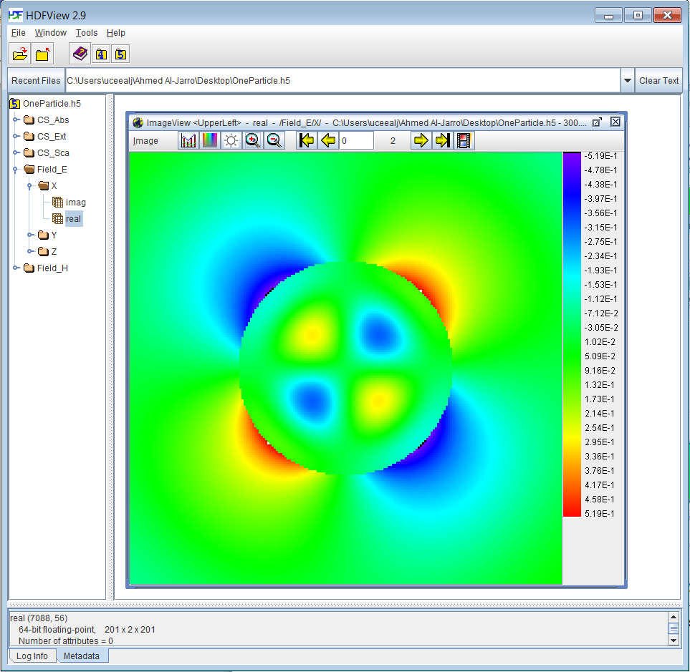

***Figure 2****. Profile of the real part of the x-component of the total electric field corresponding to the single particle scattering system whose parameters are defined in* OneParticle.xml – *(****Sec. 3.1****). Images are shown as generated by* HDFView *version 2.9.*

Alternatively, once the output data from OneParticle.h5 file are displayed in a spreadsheet format and exported to, for example, .txt files, one could also use one’s preferred visualization tool for plotting the profile of the total field. For example, ***Figure 3*** shows the total field profile of the three Cartesian components of the electric field, represented in the *x-z* plane.

|  |  |  |
| --- | --- | --- |
|  |  |  |
|  |  |  |

***Figure 3****. Profiles of the three Cartesian components of the total field corresponding to the single particle scattering system defined in* OneParticle.xml –(***Sec. 3.1***)*.*

To compute the Spectral Response Output for this same problem setup, using now the Sellmeier equation to define the particle dispersion properties (see ***Sec. 2.3.1***), the OneParticleScan.xml file should be modified as follows:

<simulation>

<harmonics nmax="15" />

</simulation>

<source type="planewave">

<wavelength value="1460" />

<propagation theta="90" phi="90" />

<polarization Etheta.real="1.0" Etheta.imag="0.0" Ephi.real="0.0" Ephi.imag="0.0"/>

</source>

<geometry>

<object type="sphere">

<cartesian x="0.0" y="0.0" z="0.0" />

<properties radius="500.0" />

<epsilon type="sellmeier">

<parameters B1="10.66842930" C1="0.301516485"

B2="0.003043475" C2="1.13475115"

B3="1.541334080" C3="1104.0" />

</epsilon>

<mu type="relative" value.real="1.0" value.imag="0.0"/>

</object>

</geometry>

<output type="response">

<scan type="A+E">

<wavelength initial="1300" final="3300" stepsize="10" />

</scan>

</output>

Upon completion of this simulation, two output files are generated, namely AbsCrossSection.dat and ExtCrossSection.dat. The corresponding extinction cross section is plotted in ***Figure 4***.

***Figure 4****. The extinction cross section for a single particle scattering system whose parameters are defined in* OneParticleScan.xml –(***Sec. 3.1***)*.*

## Multiple Particles Scattering System

In this example, a linearly polarized incident plane-wave with wavelength, $λ=1460 nm$, is propagating along the direction defined by the angles $\left(θ_{inc}=45, φ_{inc}=90\right)$ and impingeson three identical spherical particles located in vacuum. The parameters of the particles are radius, $r=500 nm$, $ε_{r}=13$ and $μ_{r}=1$. The electric field is *x*-polarized, $E^{inc}={\hat{φ}}_{inc}$. The number of Fourier harmonics used in the simulation is nmax=20 and the spherical particles are located at $r_{1}=\left(0, 0, 0\right)$, $r_{2}=\left(0, 1500, 1500\right) nm$ and $r_{3}=\left(0, -1500, -1500\right) nm$. The syntax for a ThreeParticles.xml file that describes this problem setup, defined for an Output Block of $6×6 {μm}^{2}$ grid with 201 steps on the *y*- and *z*-axis, would read as:

<simulation>

<harmonics nmax="20" />

</simulation>

<source type="planewave">

<wavelength value="1460" />

<propagation theta="45" phi="90" />

<polarization Etheta.real="0.0" Etheta.imag="0.0" Ephi.real="1.0" Ephi.imag="0.0"/>

</source>

<geometry>

<object type="sphere">

<cartesian x="0.0" y="0.0" z="0.0" />

<properties radius="500.0" />

<epsilon type="relative" value.real="13.0" value.imag="0."/>

<mu type="relative" value.real="1.0" value.imag="0.0"/>

</object>

<object type="sphere">

<cartesian x="0.0" y="1500" z="1500" />

<properties radius="500.0" />

<epsilon type="relative" value.real="13.0" value.imag="0."/>

<mu type="relative" value.real="1.0" value.imag="0.0"/>

</object>

<object type="sphere">

<cartesian x="0.0" y="-1500" z="-1500" />

<properties radius="500.0" />

<epsilon type="relative" value.real="13.0" value.imag="0."/>

<mu type="relative" value.real="1.0" value.imag="0.0"/>

</object>

</geometry>

<output type="field">

<grid type="cartesian">

<x min="-0.1" max="0.1" steps="2" />

<y min="-3000" max="3000" steps="201" />

<z min="-3000" max="3000" steps="201" />

</grid>

</output>

Note that if the Sphere Objects were mistakenly positioned at $r_{1}=\left(0, 0, 0\right)$, $r_{2}=\left(0, 100, 100\right) nm$, and $r_{3}=\left(0, -1500, -1500\right) nm$, the error message ‘Objects 1 and 2 intersect. Cannot validate geometry!’ would be generated and then the simulation would stop.

Upon completion of the simulation defined in ThreeParticles.xml, the output data will be written in the ThreeParticles.h5 file. In ***Figure 5***, the spatial distribution of the real part, imaginary part and magnitude of the *x*-component of the total electric field are plotted.

|  |  |  |
| --- | --- | --- |
|  |  |  |
|  |  |  |

***Figure 5****.Profile of the real part, imaginary part and magnitude of the x component of the total field corresponding to the three particle scattering system defined in* ThreeParticles.xml –(***Section 3.2***)*.*

## Spiral Structure Scattering System

In this example, a circularly right-polarized plane-wave with wavelength, $λ=1460 nm$, propagates along the *y*-axis $\left(θ_{inc}=90, φ_{inc}=0\right)$ and impingeson a Spiral Structure (see ***Sec. 2.3.2***) located in vacuum. The structure parameters are arms=3, points=5, distance=600 nm, and normal=*y*. The scattering problem is solved with nmax=15, the parameters describing the spherical particles are radius, $r=500 nm$, $ε_{r}=13$ and $μ_{r}=1$. The syntax for a SpiralStructure.xml file that describes this problem setup, defined for an Output Block of $4×4 {μm}^{2}$ grid with 201 steps on the *x*- and *z*-axis, would read as:

<simulation>

<harmonics nmax="15" />

</simulation>

<source type="planewave">

<wavelength value="1460" />

<propagation theta="90" phi="0" />

<polarization Etheta.real="0.70710678118" Etheta.imag="0.0"

Ephi.real="0.0" Ephi.imag="-0.70710678118"/>

</source>

<geometry>

<structure type="spiral" arms="3">

<object type="sphere">

<properties radius="250.0" />

<epsilon type="relative" value.real="13.0" value.imag="0."/>

<mu type="relative" value.real="1.0" value.imag="0.0"/>

</object>

<properties points="5" distance="600.0" normal="y" />

</structure>

</geometry>

<output type="field">

<grid type="cartesian">

<x min="-2000" max="2000" steps="201" />

<y min="-0.1" max="0.1" steps="2" />

<z min="-2000" max="2000" steps="201" />

</grid>

</output>

Note that the number of particles considered in this example is 13. Hence, it is expected that the runtime will be larger than that required to solve the examples considered in ***Secs. 3.1*** and ***3.2***. Upon completion of this simulation, the output data will be written in the SpiralStructure.h5 file. The profiles of the Cartesian components of total electric field, determined in the *x-z* plane, are shown in ***Figure 6***.

|  |  |  |
| --- | --- | --- |
|  |  |  |
|  |  |  |

***Figure 6****. Profiles of the three Cartesian components of the total field calculated for a spiral structure scattering system defined in* SpiralStructure.xml *–* (***Sec. 3.3***)*.*

# System Requirements and Contact Information

**OPTIMET-3D** is portable on most Unix 64-bit systems. **OPTIMET-3D** contains no known bugs; however, there is no guarantee that the code is bug free! If you encounter any problems while using **OPTIMET-3D**, please contact us at optimet3ducl@gmail.com with a brief description of the problem.

# Bibliography

1. C. F. Bohren and D. R. Huffman, *Absorption and Scattering of Light by Small Particles*, (Wiley-Interscience, 1983).
2. M. Mishchenko, L. Travis, and A. Laci, *Scattering, Absorption and Emission of Light by Small Particles*, (Cambridge University Press 2002).
3. A. Al-Jarro, C. G. Biris, and N. C. Panoiu, “Resonant mixing of optical orbital and spin angular momentum by using chiral silicon nanosphere clusters,” *Opt. Express* **24**, 6945–6958 (2016).
4. N. A. Gumerov and R. A. Duraiswami, “A scalar potential formulation and translation theory for the time-harmonic Maxwell equations,” *J. Comput. Phys*. **225**, 206–236 (2007).
5. 7. N. A. Gumerov and R. A. Duraiswami, “Recursions for the Computation of Multipole Translation and Rotation Coefficients for the 3-D Helmholtz Equation,” *SIAM J. Sci. Comput*. **25**, 1344–1381 (2004).

**OPTIMET-3D** Documentation End